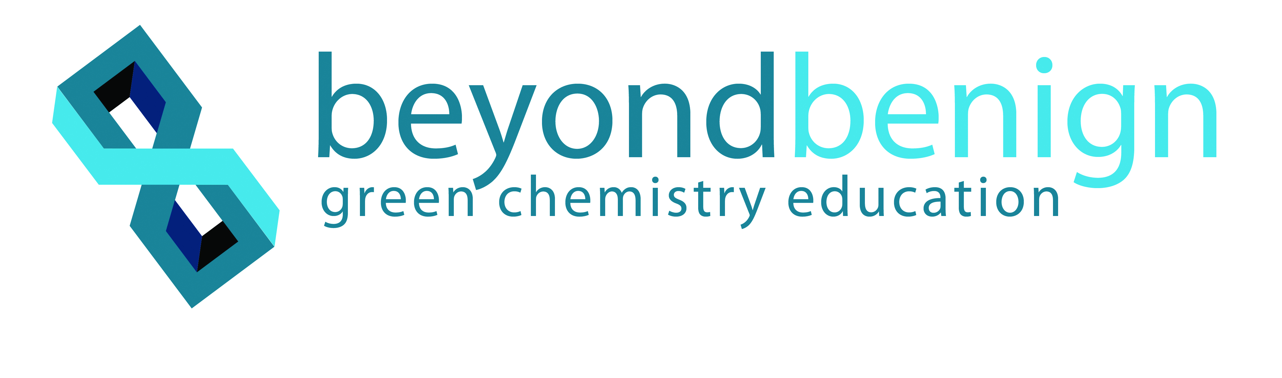Flame Tests and Emission Spectra

**HIGH SCHOOL**

**Green Chemistry & Sustainable Science**

Teacher Background Information:

Traditionally, flame emission spectra labs use solutions of toxic metal salts in Bunsen burners. Even when used on microscale, the metal ions in the salt solutions become volatized. Additionally, the traditional protocol is not thermodynamically favorable. This redesigned lab uses candles with colored flames that burn at a much lower temperature than a Bunsen burner. Also, the preparation and disposal of the salt solutions is eliminated. Finally, the candles burn more slowly and may be observed concurrently, giving students sufficient time to compare and contrast the emission spectra. This replacement lab also eliminates the use of spectral tubes in the classroom, which are extremely unfavorable from a thermodynamic standpoint.

Safety Information:

Students will be lighting candles; remind them to use care when handling matches or a lighter.

**Learning Objectives:** Students will…

* Observe a colored flame with the naked eye
* Use diffraction grating film or a spectroscope to identify the emission spectrum of each flame
* Match the emission spectrum to an element using an emission spectra chart

**Key Terms**: inquiry, emission spectra, flame test

Materials:

* Colorflame birthday candles (available at [www.colorflame.com](http://www.colorflame.com))
* Sand or clay (to stand up the candles)
* Aluminum pan (a small baking loaf pan works well, approximately 7 x 2 x 1 in.)
* Matches or butane lighter
* Diffraction grating film or spectroscopes
* Internet access to [webminerals](http://webmineral.com/help/FlameTest.shtml#.WvMEdy-ZMdU) website or printouts of emission spectra

**Time Required:** 45-minute class period

**NGSS Standards Met:**

* **HS-PS1-2.** Construct and revise an explanation for the outcome of a simple chemical reaction based on the outermost electron states of atoms, trends in the periodic table, and knowledge of the patterns in chemical properties.
* **HS-PS2-6.** Communicate scientific and technical information about why the molecular-level structure is important in the functioning of the designed materials.

|  |
| --- |
|  |

Teacher Preparation:

* Be sure to prepare the boxes of sand or set up the clay candle holders in advance of the lab. The candle set comes with candle holders, but they are flammable. We suggest either of two set-ups: the first is described in the student handout, with a pan of sand large and deep enough to stand the five candles in a row. Alternatively, candle “holders” may be created out of clay or PlayDough and set in the bottom of a shallow aluminium pan.
* Colorflame birthday candles are available at [www.colorflame.com](http://www.colorflame.com).
* Diffraction grating film or spectroscopes are available at a variety of sources, including: Online Science Mall, Carolina Scientific, Flinn Scientific (Flinn C-Spectra Sheet), etc.
* Printouts of emission spectra are available from a variety of sources. One student-friendly website is <http://webmineral.com/help/FlameTest.shtml>.

On this site, students should first narrow down their search by categorizing the flame color to the naked eye. Once they narrow down the color, they will use the diffraction grating to make an identification. The objective is for the student to support their identification by matching the spectrum they see to the one published.

* The classroom should be darkened as much as possible to be able to see the spectra.
* To conserve the candles, it is best to have students light all five at once and use diffraction grating film to make their initial observations. They may confirm these using spectroscopes and viewing one candle at a time; however, this technique is much more challenging because the flame has to be precisely lined up with the spectroscope slit.

Keys for Success:

This is truly an inquiry lab. Be sure to explain to students that we do not know the exact identification of the elements in the candles. You might be able to find something online, but it might not be correct, as direct lot numbers of the candles tend to alter slightly. Students will need to justify their identifications based on their own observations, so it is possible that different groups might make different identifications, depending on their perception of the emission spectra.

Disposal Information:

Household materials are used in this lab. Dispose of matches (if they are used) appropriately.

Flame Tests and Emission Spectra

**Student Sheet**

Introduction:

White light is composed of multiple wavelengths of light producing the entire rainbow. When individual elements are heated they absorb energy that causes electronic transitions. When the electrons return to the ground state, this energy is released as visible light. Every element has its own unique emission spectrum that can be used as its “fingerprint” for identification.

Materials:

* Colorflame birthday candles
* Sand
* Aluminum pan big enough to stand five candles in a row (a small baking loaf pan works well)
* Matches or butane lighter
* Diffraction grating film or spectroscopes
* Printouts of emission spectra (or internet access to website)

Procedure:

1. Place the five candles in the sand, pressing them down ¼ inch and 1 inch apart. The order of the candles should match the data table: red, purple, green, blue, orange.
2. Light the candles using a match or lighter and observe their flames in a darkened room.
3. Record the color of each flame as observed with the naked eye in the “Flame color” column of your results table.
4. Hold the diffraction film 6 to 12 inches away from the flames and observe the dominant colors for each flame.
5. Record the observed set of colors for each flame in the “Diffraction emissions” column of the results table.
6. Blow out the candles.
7. Use the emission spectra website to identify the element in each flame. First narrow down your search by matching the flame as observed by the naked eye. Then, match the emission spectra published on the website to the spectra you recorded in order to make your final identifications.
8. If necessary, relight individual candles and observe with a spectroscope to confirm the emission spectra.
9. Record the elements identified in the final column of your results table.

Data and Observations:

|  |  |  |  |
| --- | --- | --- | --- |
| **Candle** | **Flame color**  **(to naked eye)** | **Diffraction emissions** | **Element identified** |
| Red |  |  |  |
| Purple |  |  |  |
| Green |  |  |  |
| Blue |  |  |  |
| Orange |  |  |  |

Questions:

1. How do the colors seen by the naked eye compare to the emission spectra emitted by each flame?
2. Why did the flames produce different colors?
3. Explain what happened within the atoms to produce the emission spectra?
4. Suggest potential sources of error in the analysis of the flames.
5. Evaluate how well this lab conforms to the 12 Principles of Green Chemistry.
6. Justify your metal identifications based on your observations.

Flame Tests and Emission Spectra

**Teacher Answer Key**

Data and Observations:

Student observations may vary. The goal of this inquiry lab is not an absolute idetification, but the table below lists the range of colors that students should see, as well as reasonable metal identifications. Students should be able to justify their element identifications based on their experimental results.

|  |  |  |  |
| --- | --- | --- | --- |
| **Candle** | **Flame color**  **(to naked eye)** | **Diffraction emissions** | **Element identified** |
| Red | Red | Red/Yellow/  Green  (possibly Indigo) | Lithium  Strontium  Calcium |
| Purple | Yellow and  Violet | Orange/Green/  Indigo | Potassium |
| Green | White with  traces of Indigo and/or Yellow | Red/Yellow/  Green/Indigo | Phosphorus  Copper  Zinc |
| Blue | Green/Indigo | Yellow/Green/  Indigo | Copper  Selenium |
| Orange | Yellow/Orange  (intense) | Orange | Sodium |

**Teacher Answer Key**

Questions:

**1.** How do the colors seen by the naked eye compare to the emission spectra emitted by each flame?

Student answers may vary—there should be a larger list of colors when viewed with the diffraction film.

**2.** Why did the flames produce different colors?

Students should make the connection that there are different metals in the different-colored candles.

**3.** Explain what happened within the atoms to produce the emission spectra?

When the atoms are heated, electrons gain energy and transition to higher energy levels. When the energy is released as photons, the colors are observed.

**4.** Suggest potential sources of error in the analysis of the flames.

Students should identify potential sources of contamination, such as the wick, the wax, dyes added to the wax, etc. Varying perceptions of the colors may also be noted.

**5.** Evaluate how well this lab conforms to the 12 Principles of Green Chemistry.

This lab demonstrates Pollution Prevention, Energy Efficiency, and Designed for Accident Prevention.

**6.** Justify your metal identifications based on your observations.

Justifications could be based on the matches between the observed spectra and the published spectra.